**Assignment- JOB Workflow**

**Submitted By-**

**Subrat Shukla, DE-1**

Hands-on 1: Creating a job run with the sample load tutorial given.

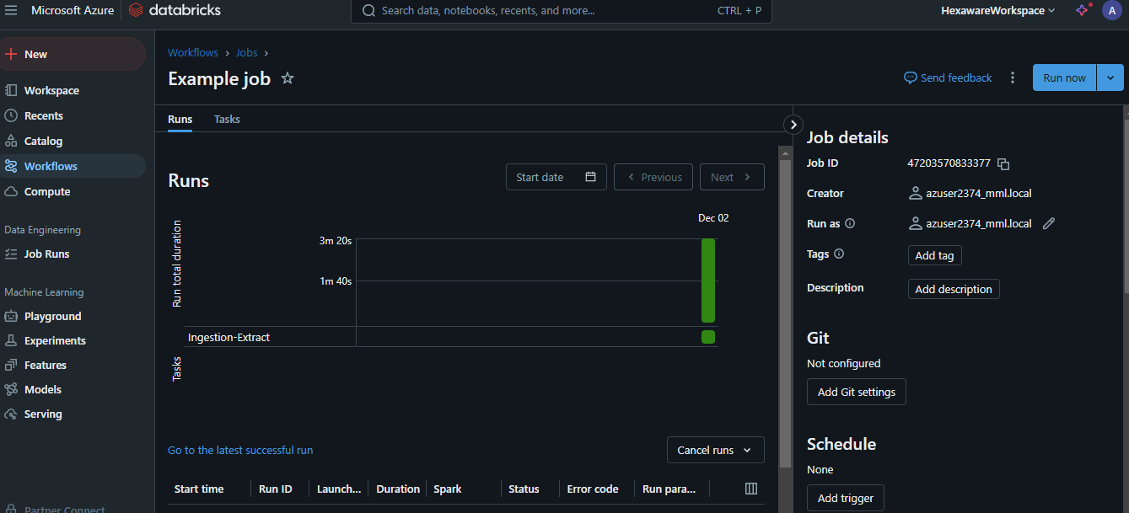

Output:

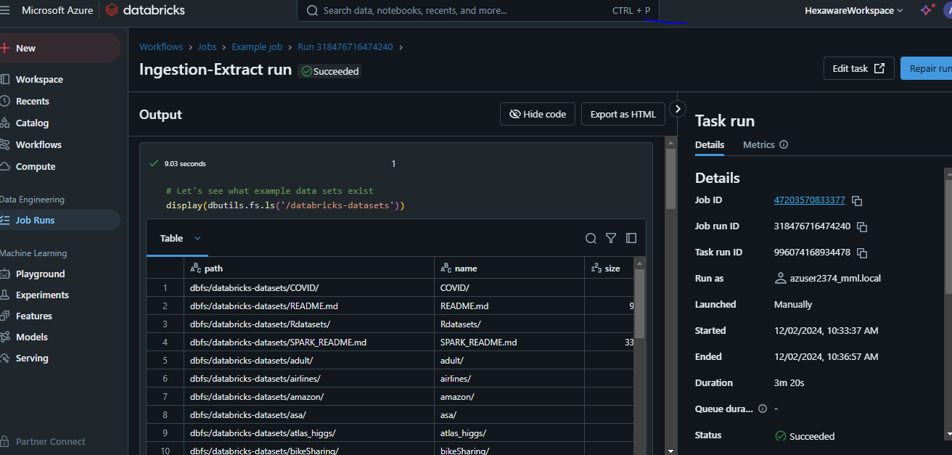

Hands-on 2: Creating a job run with the existing notebook.

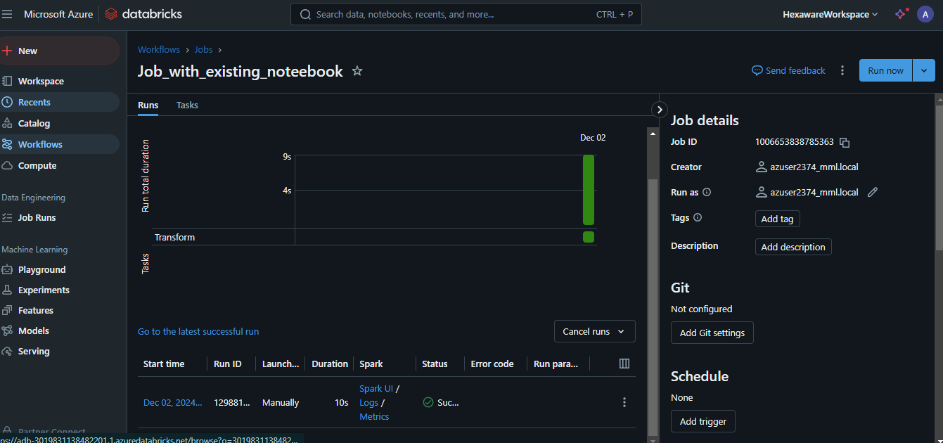

Output:

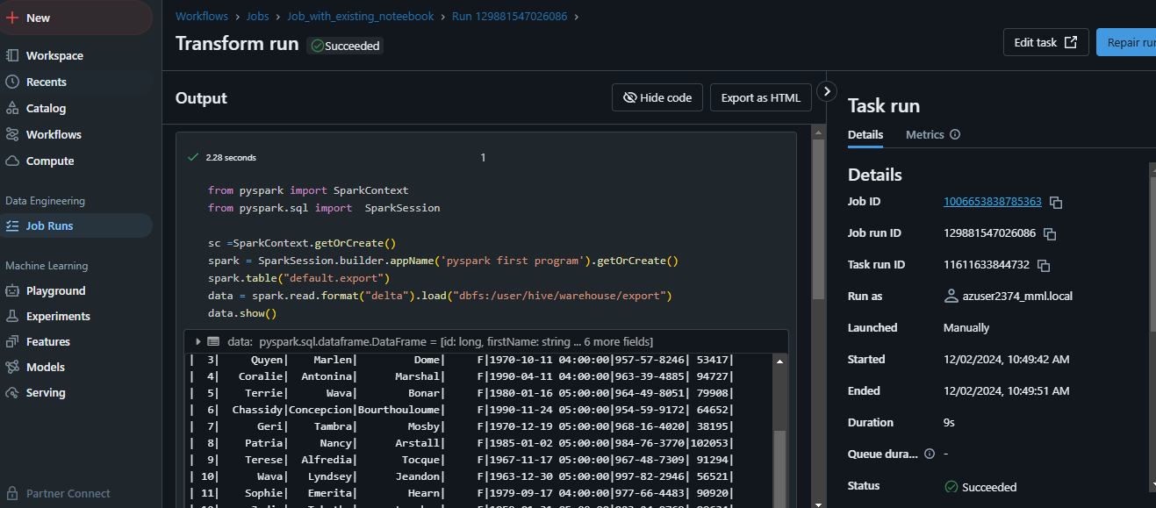

Creating storage accounts:

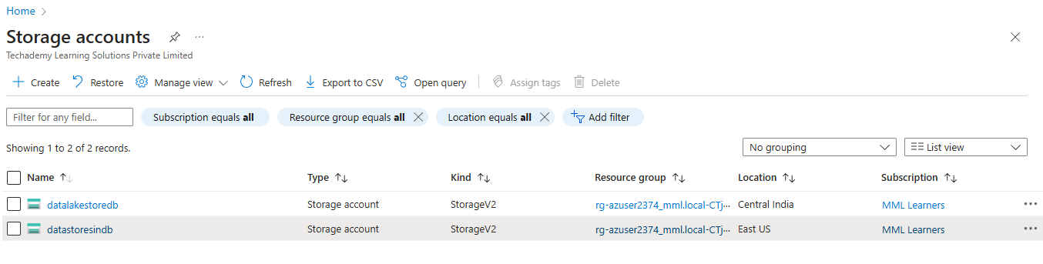

Hands-on 3: Creating a datalake storage account.

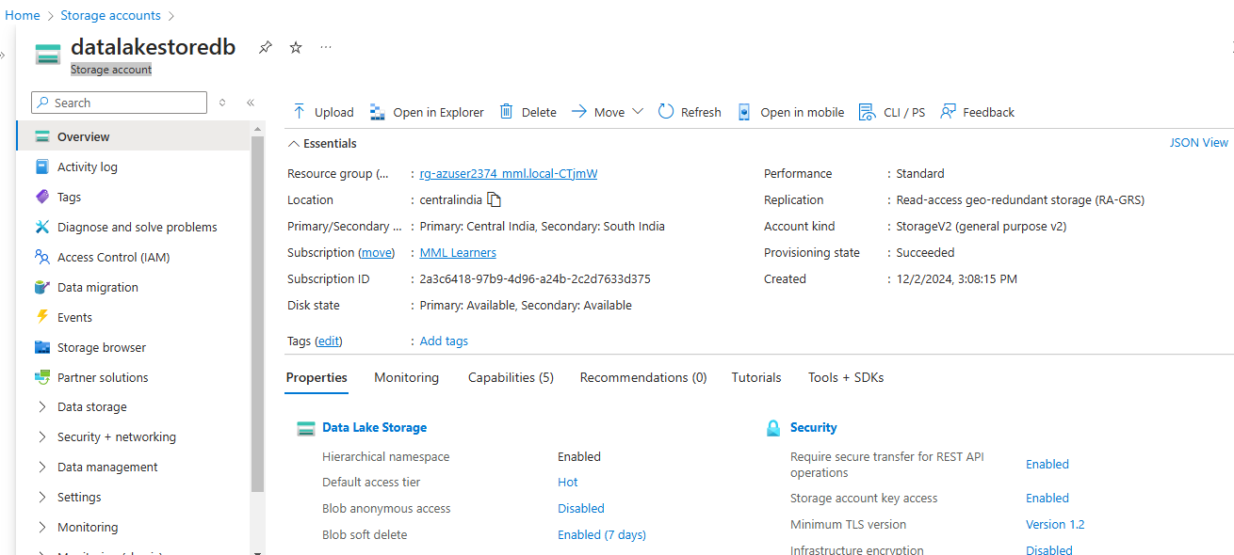

Hands-on 4: Creating a datastore storage account.

